**Hotel Management System**

**Project Overview:**

* The Hotel Reservation System is a web-based application designed to transform the way hotels manage bookings and reservations. Traditionally, hotels have relied on manual or semi-digital methods for handling bookings, which can often result in inefficiencies, double bookings, and lack of a centralized reservation process.
* The proposed system addresses these issues by providing a fully automated, online platform that allows users to effortlessly browse available rooms, check rates, and make reservations in real time. The application aims to enhance the customer experience by offering a streamlined interface where users can manage their bookings, view confirmation details, and make any necessary modifications, such as cancellation or rescheduling.
* On the hotel’s end, the system will enable staff to easily monitor room availability, track guest check-ins and check-outs, manage customer preferences, and provide personalized services. The real-time integration of the system with the hotel’s back end will prevent common problems such as overbooking and manual errors in booking allocations.

**Project Team Members:**

* Sai Chandu Amireddi
* Siva Kumar Vutla
* Sarath Chandran Karintha
* Gana Krishna Vamsi Goka
* Mani Krishna Katteboyina

**Softwares Used In Project.**

* Java (Version 11 or Higher)
* Apace Tomcat (version 10.1 or higher)
* GitHub
* Eclipse IDE/VSCode/IntelliJ Community Edition
* MySql

**Technologies Used In Project:**

* Java Servlets
* JSP/HTML/CSS/JavaScript
* XML/JSON
* Tomcat
* Version Control(GitHub)

**Project Setup**

Download all the software's mentioned in the software requirement list mentioned above. Setup your local system by Installing all the necessary software's. Clone the Repository from the GitHub and Save it in the local. (Internal/External Storage) Import the project from local to any IDE (Eclipse/VSCode/IntelliJ) Download all the necessary dependencies used in the Project.

**Run/Execute the project.**

* Make any changes to the code if required.
* Generate the .war file and copy the file into the apache tomcat server webapps folder.
* Start Apache Tomcat by running thee batch file startup.bat for windows and ./startup.sh for mac
* Access the web application by opening <http://localhost:8080/HotelManagementSystemApplication/homepage.jsp> url in browser.

**OUTPUT SCREEN SHOTS:**

**CUSTOMER VIEW:**

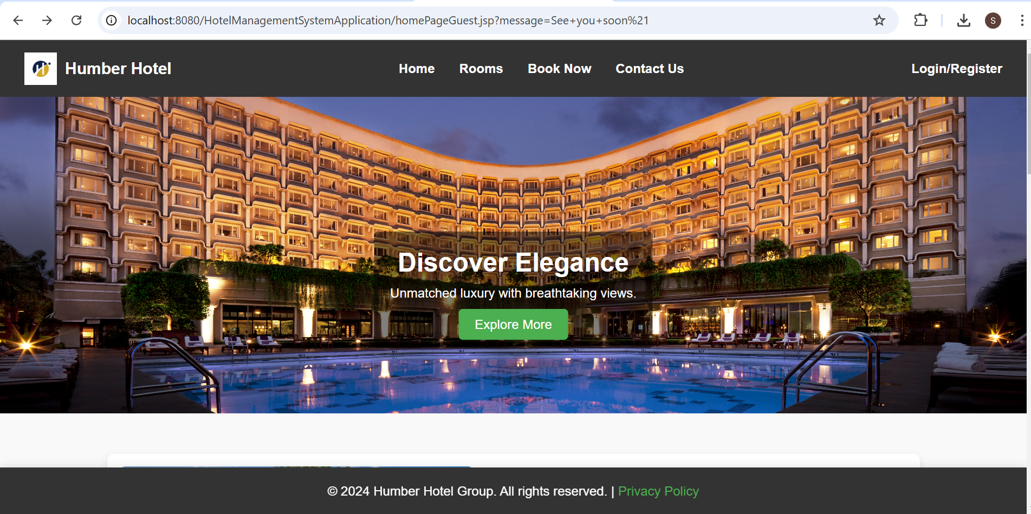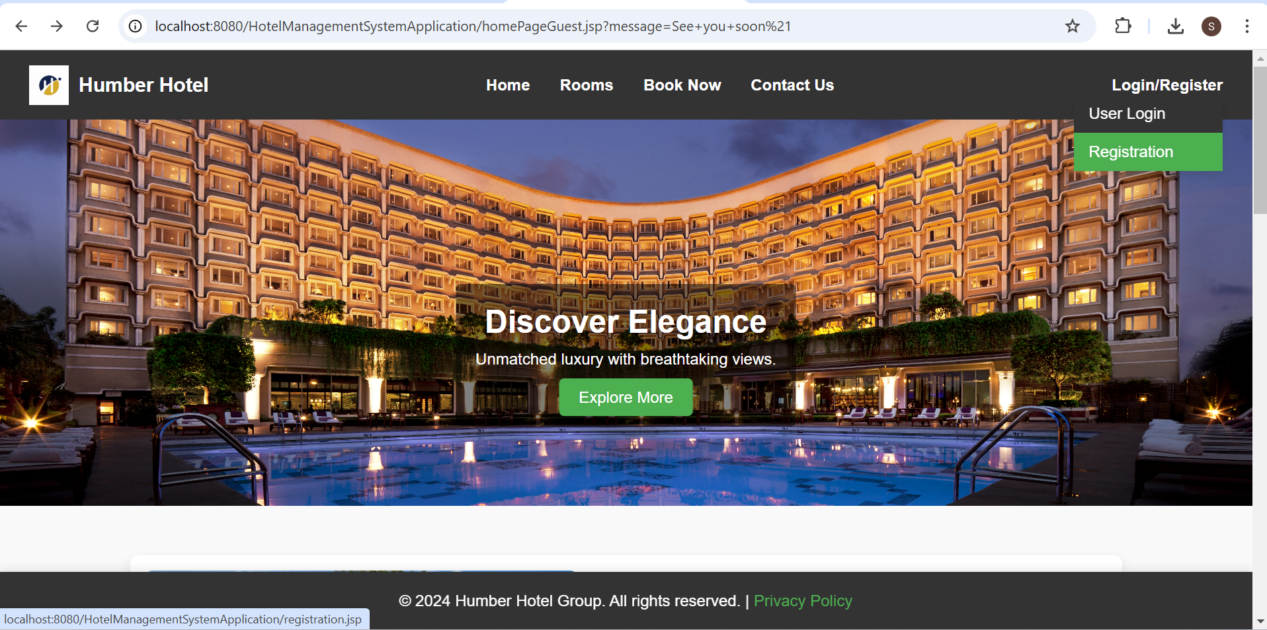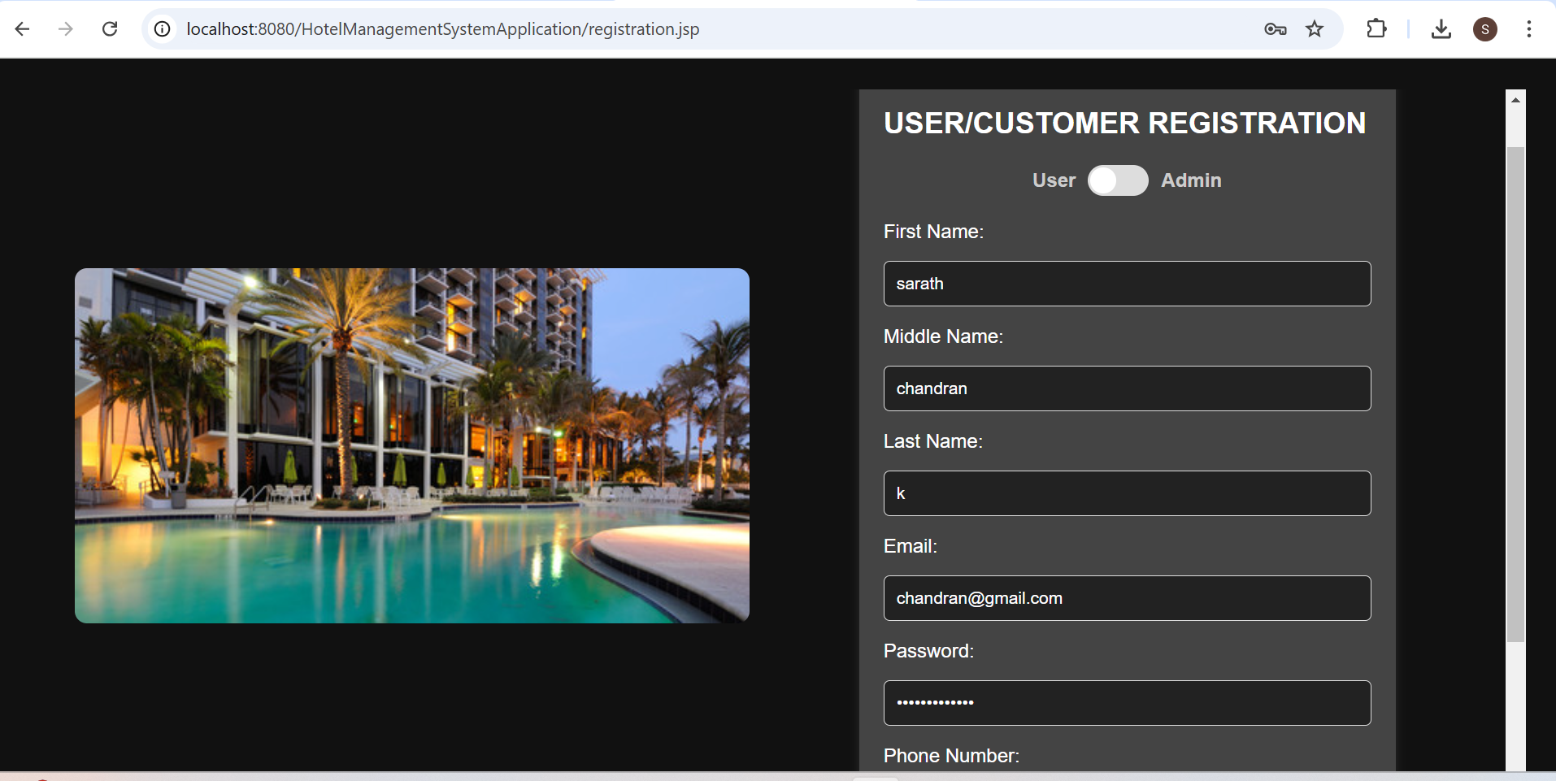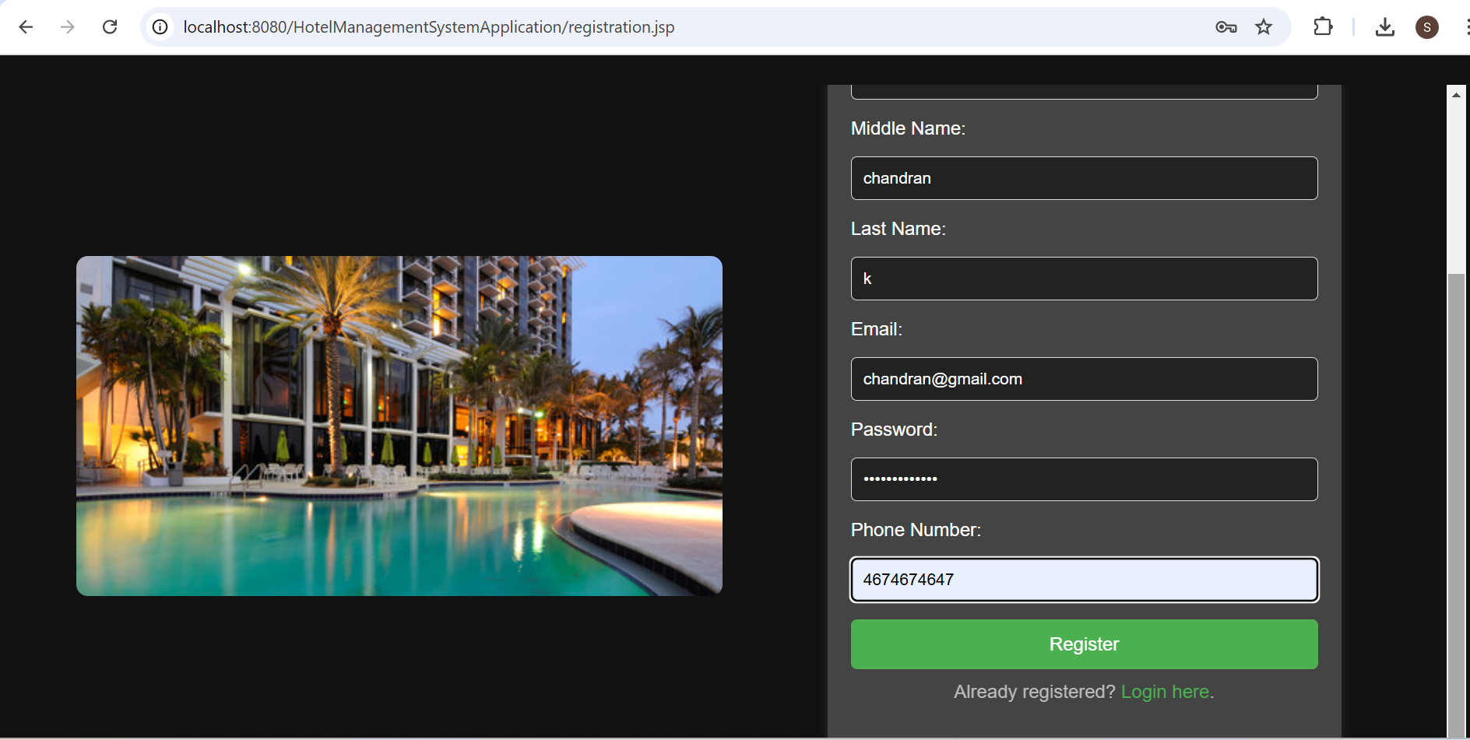

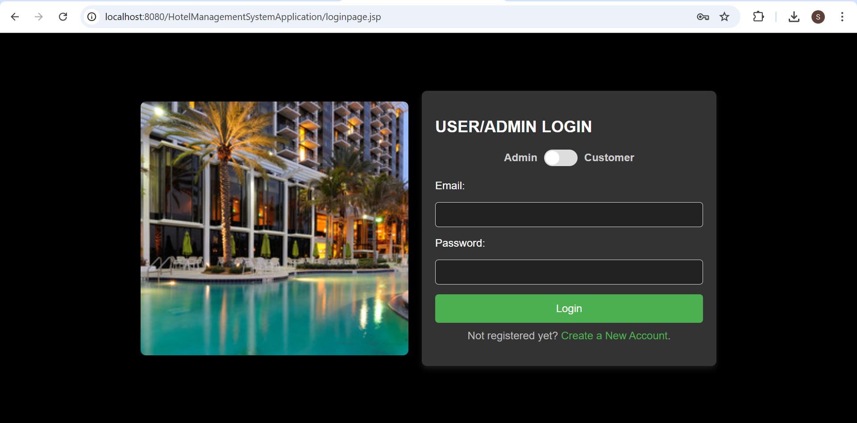

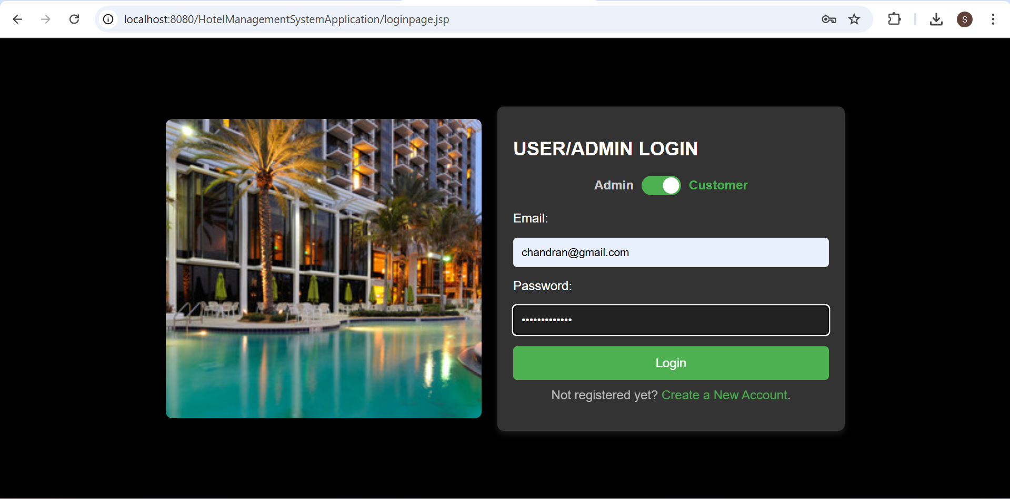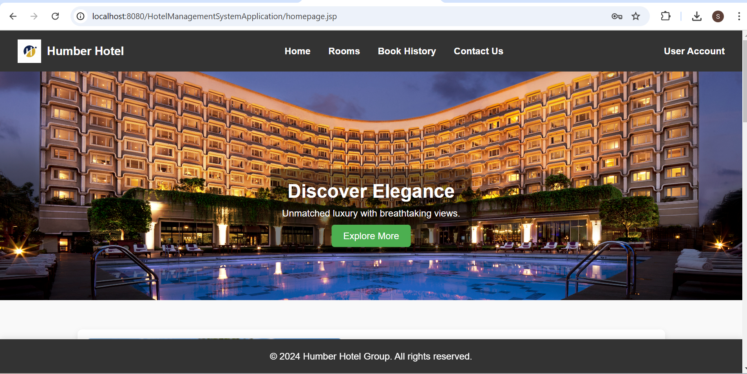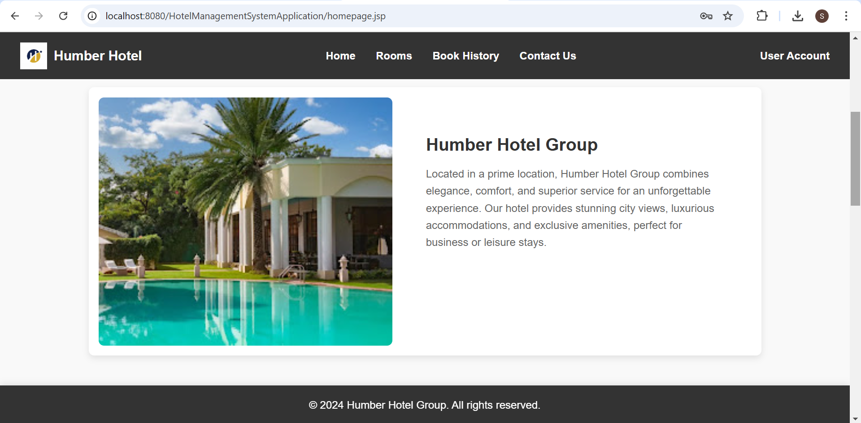

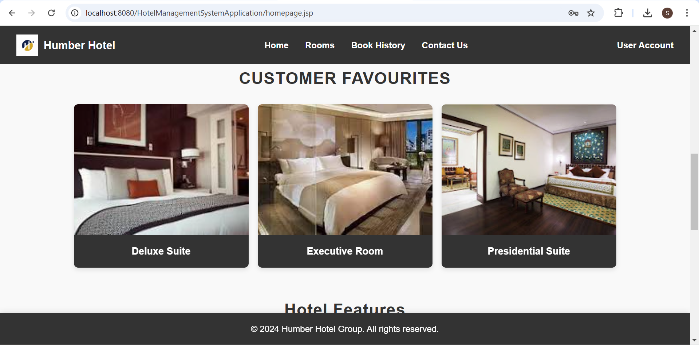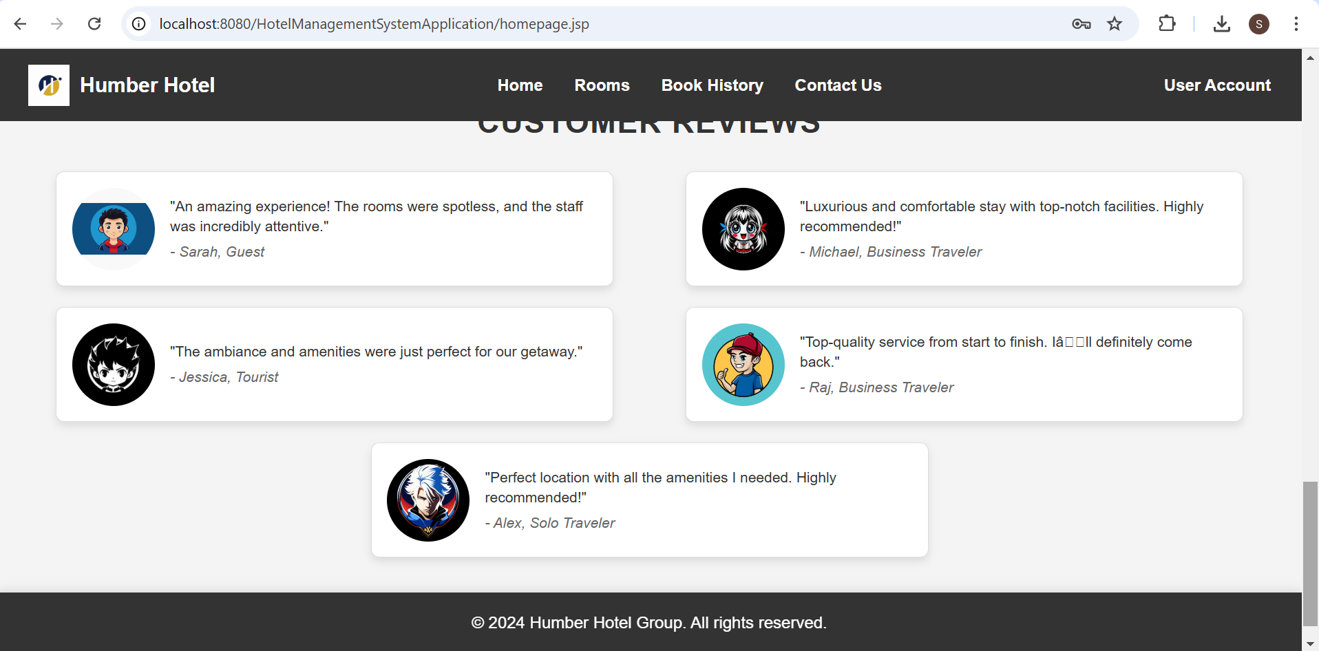

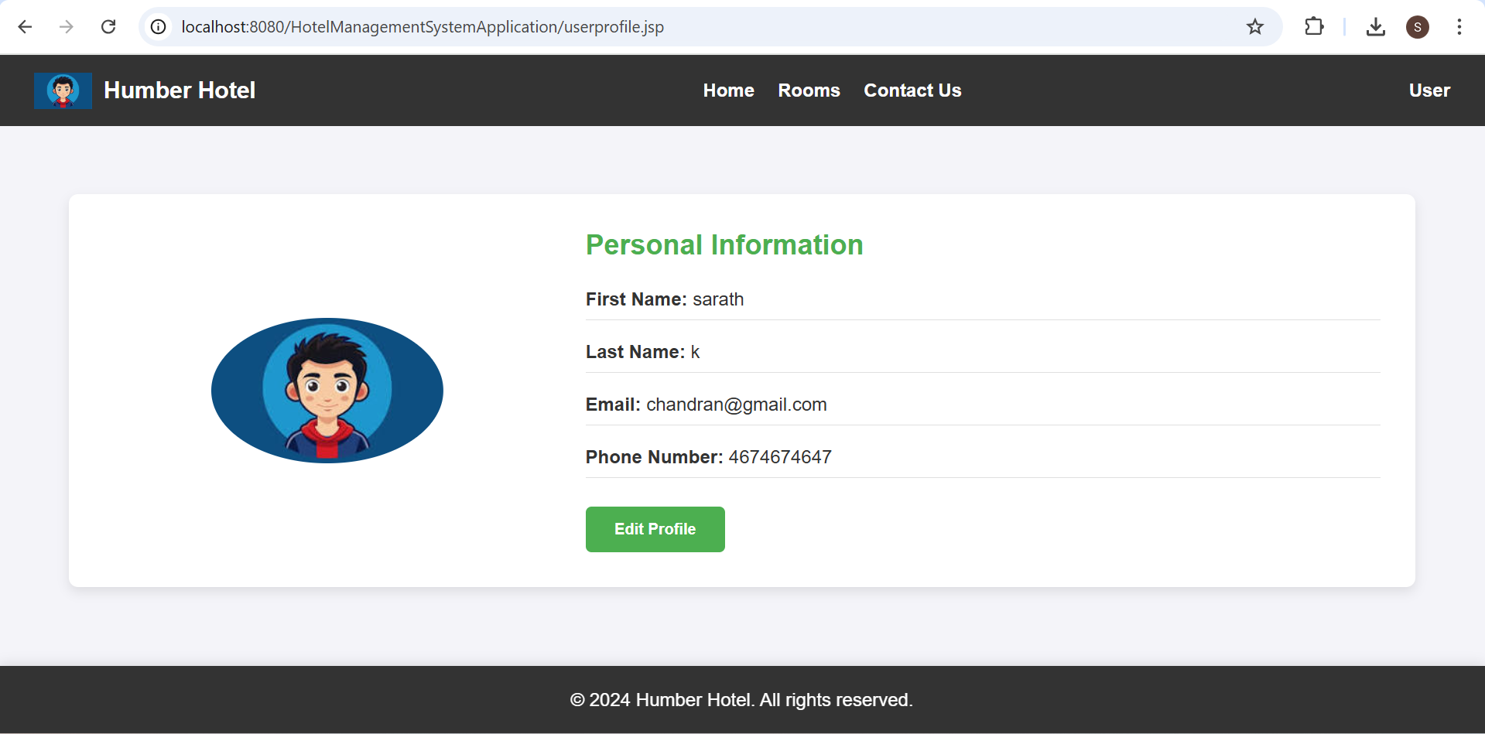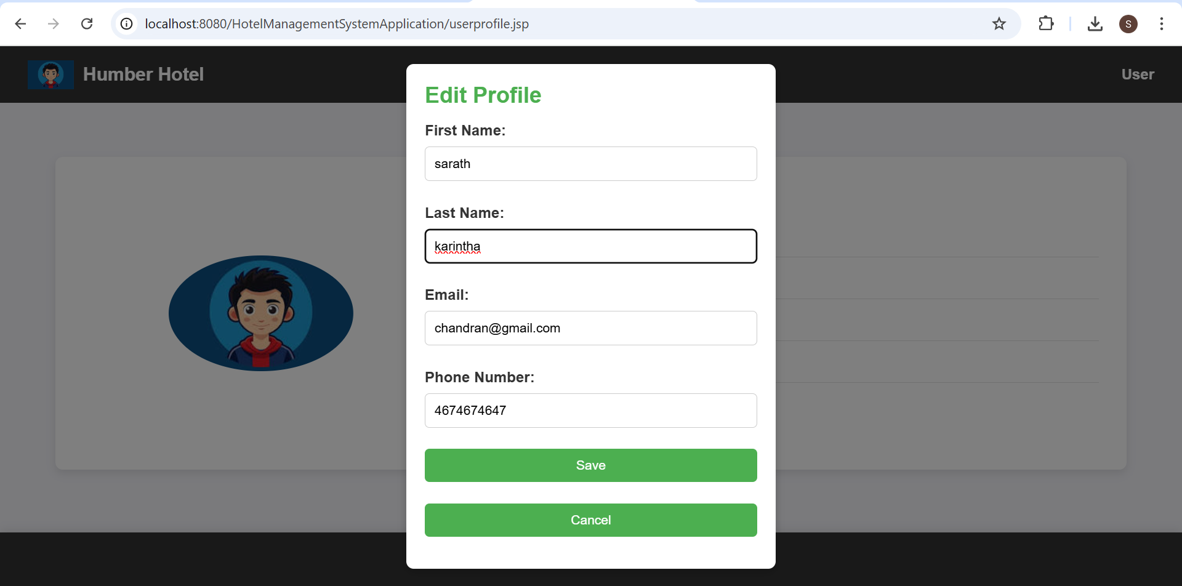

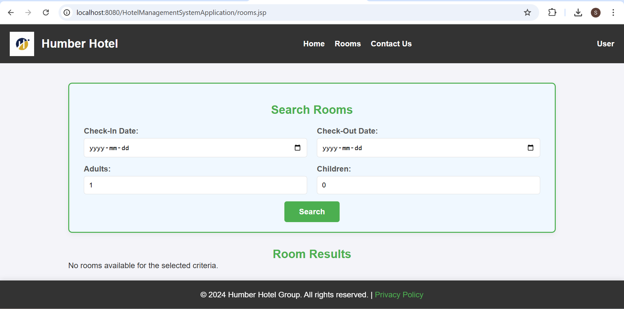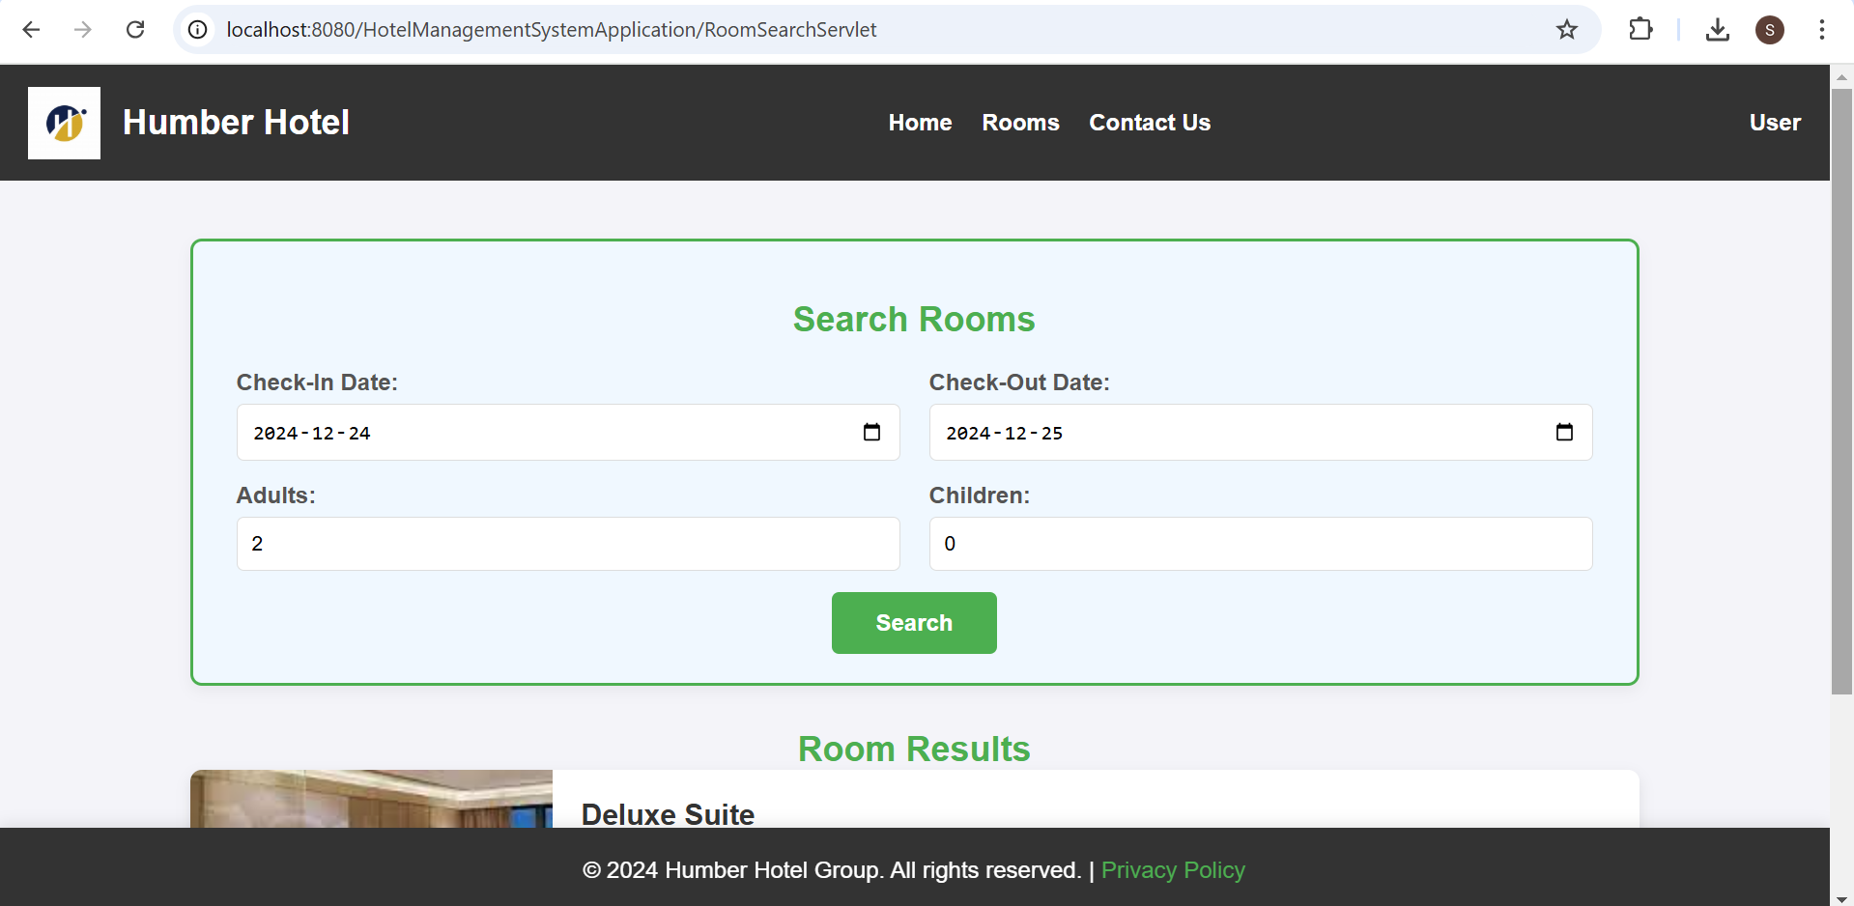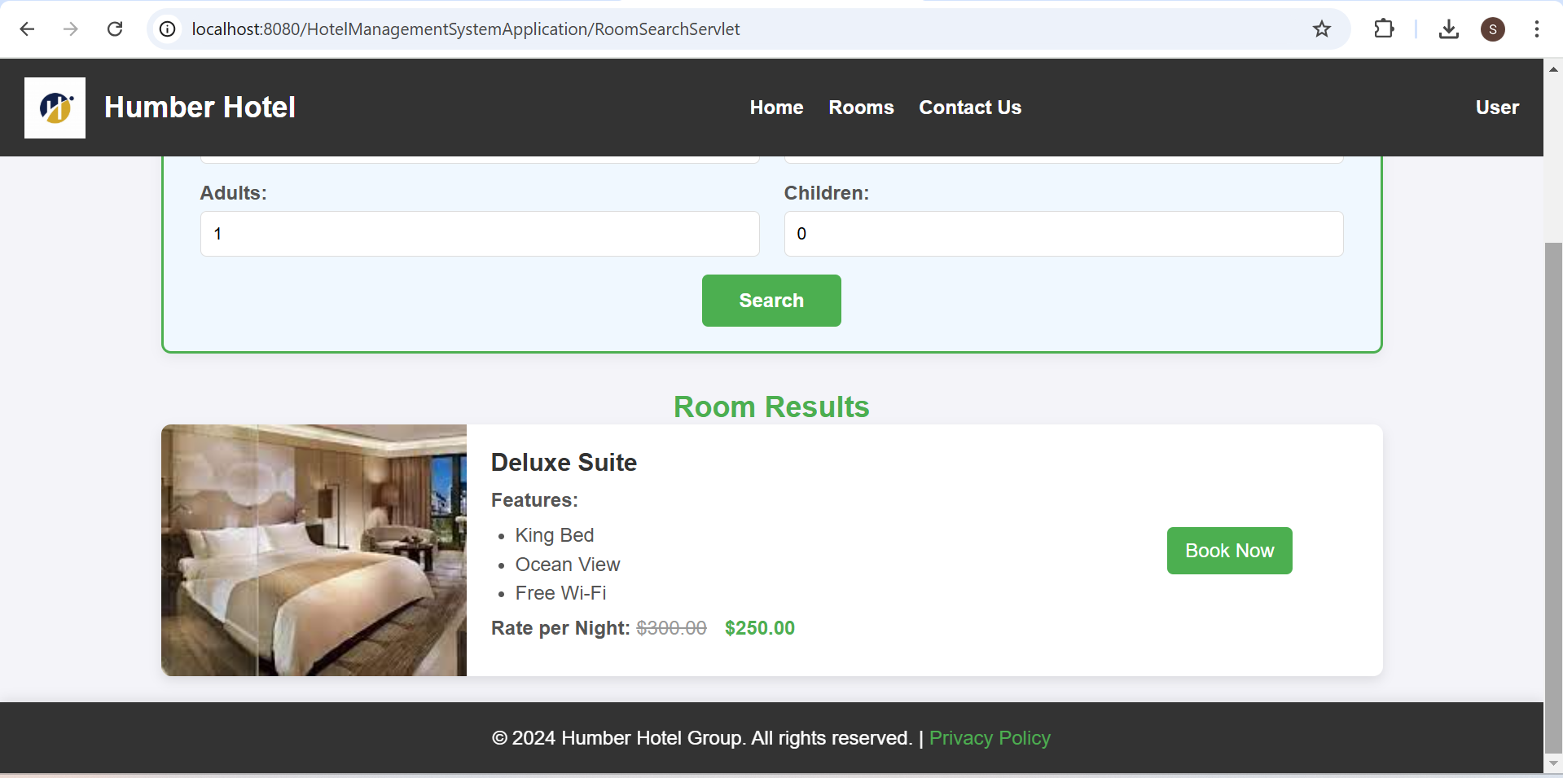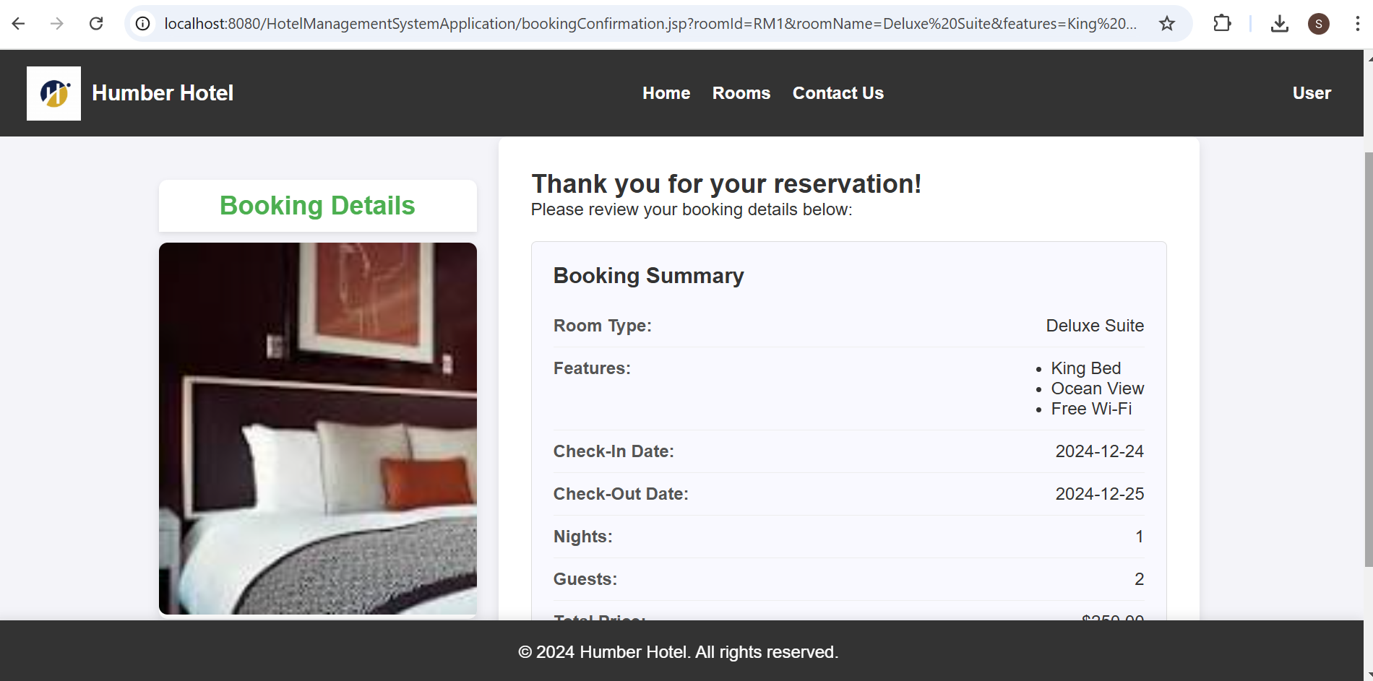

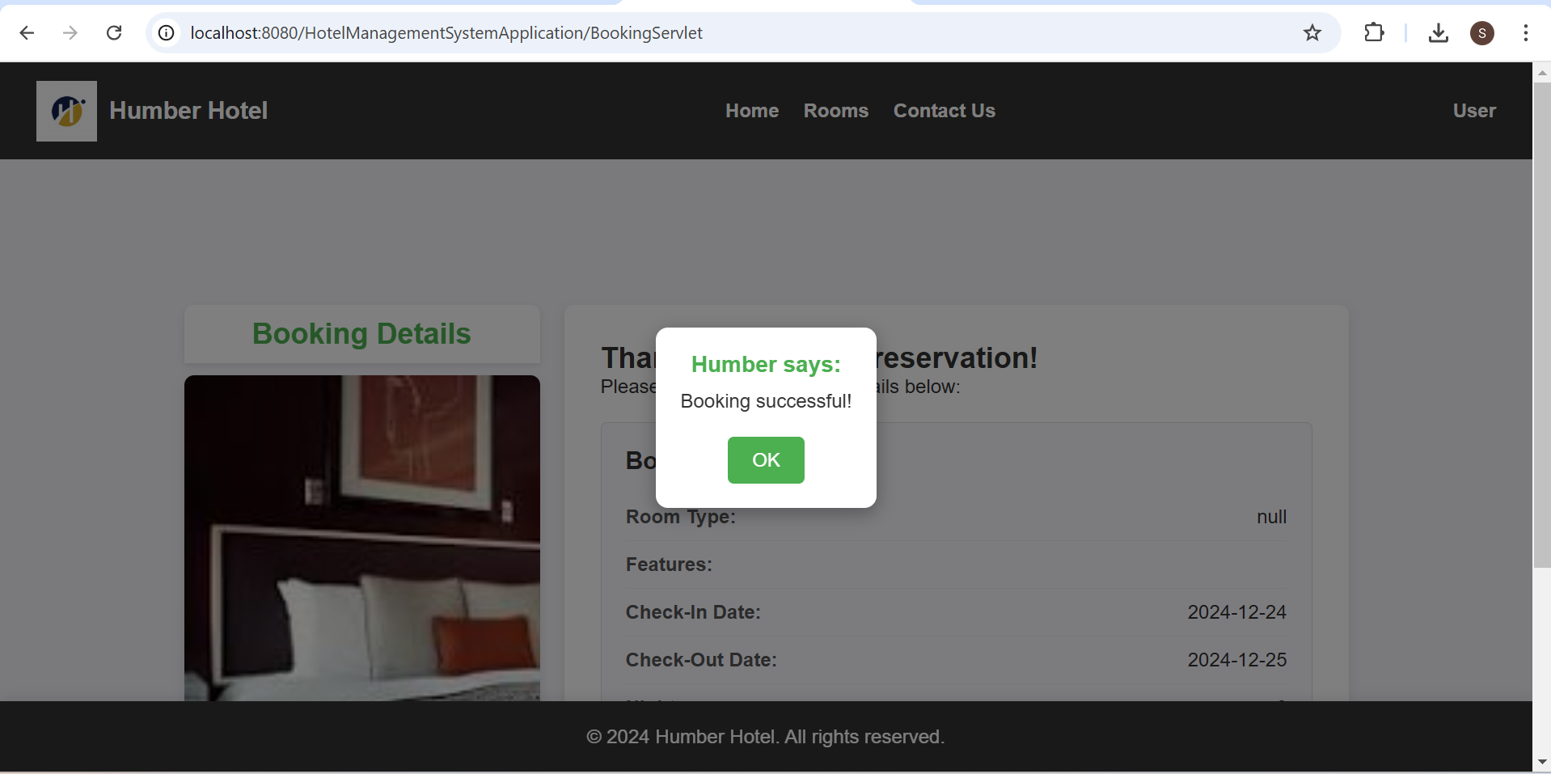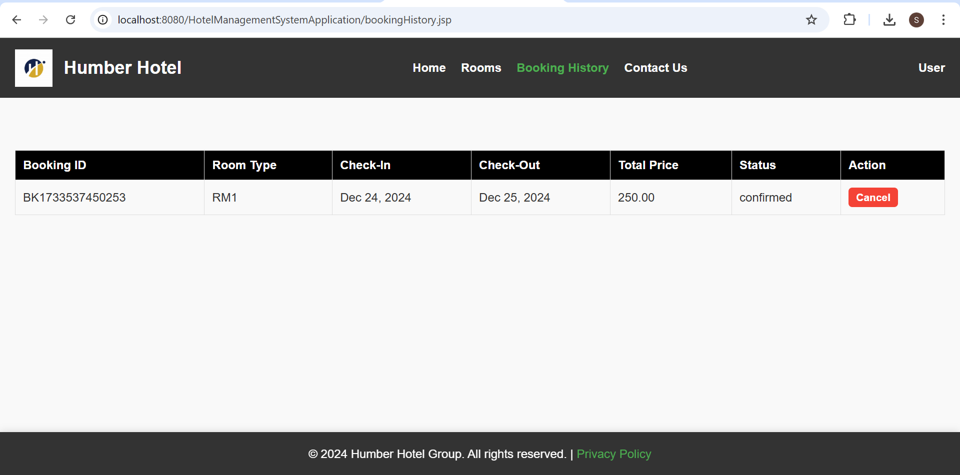

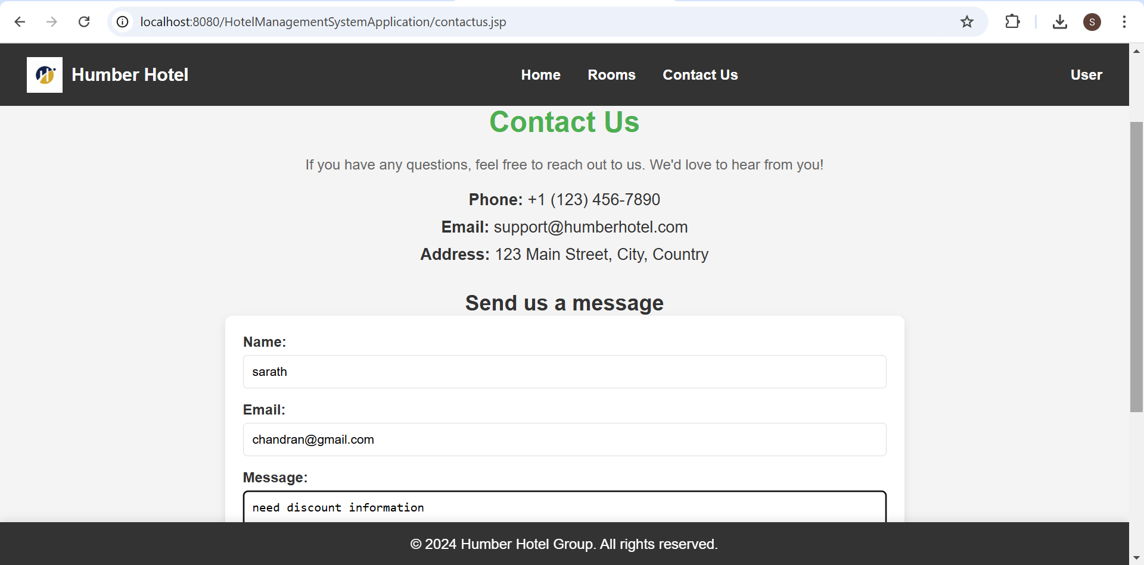

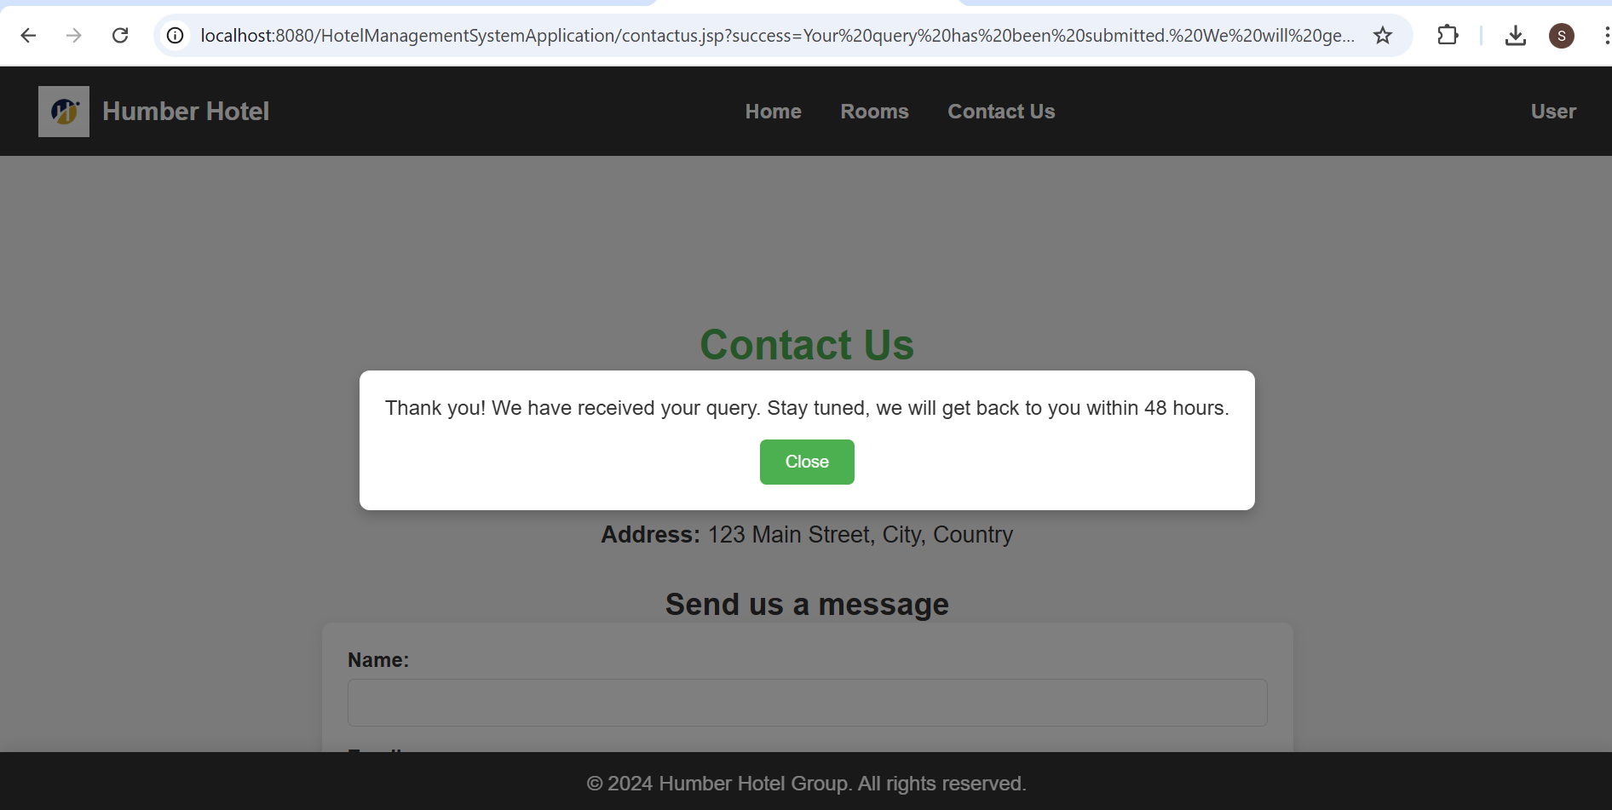

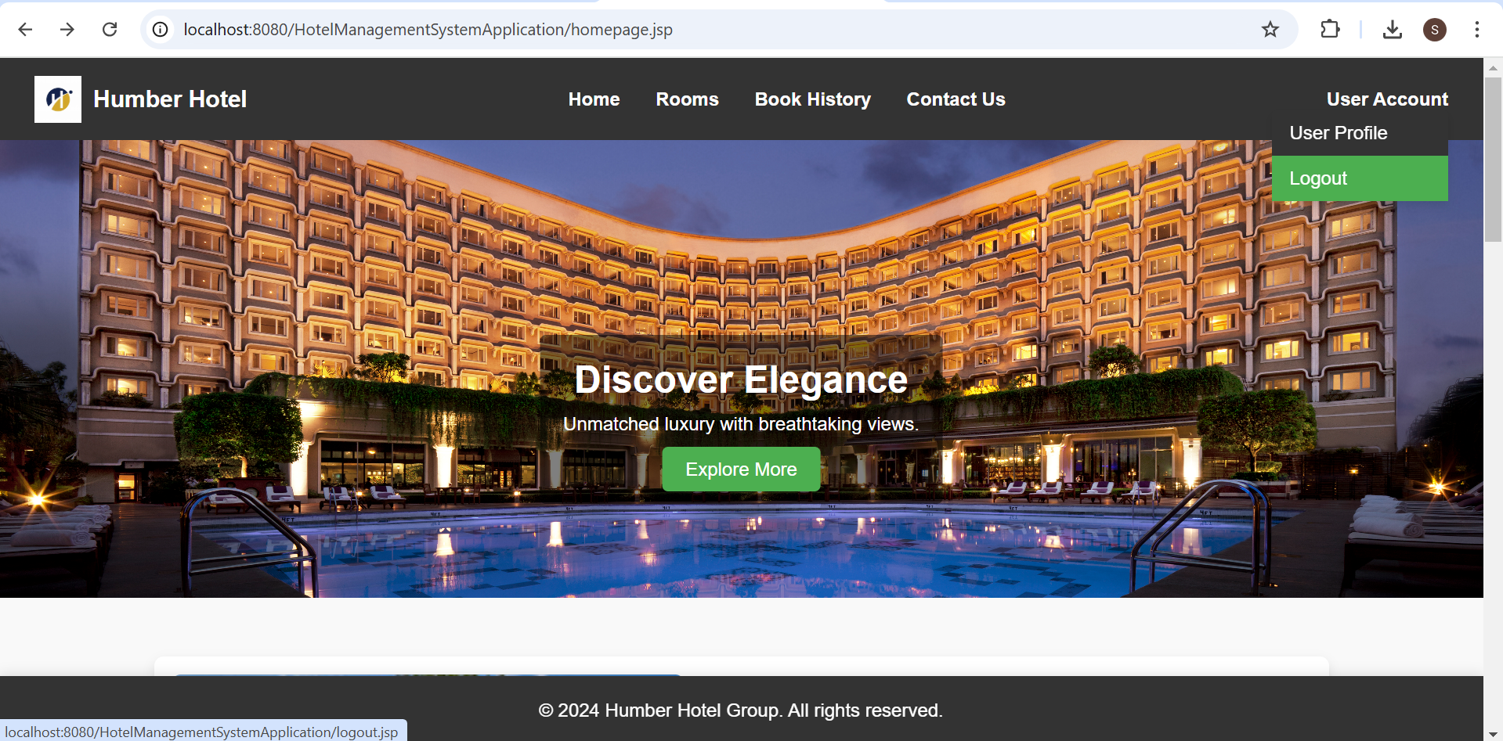

**ADMIN VIEW:**

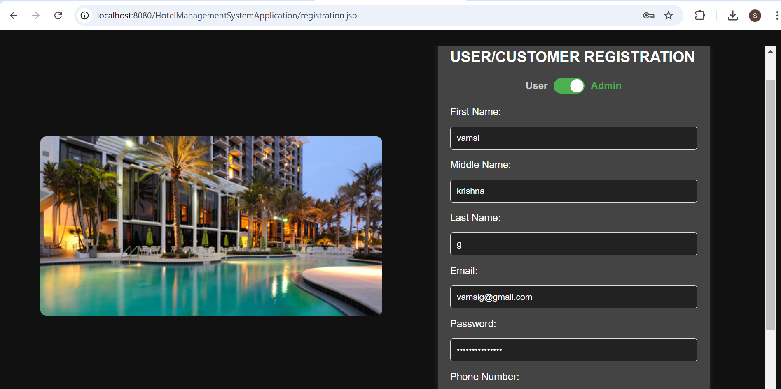

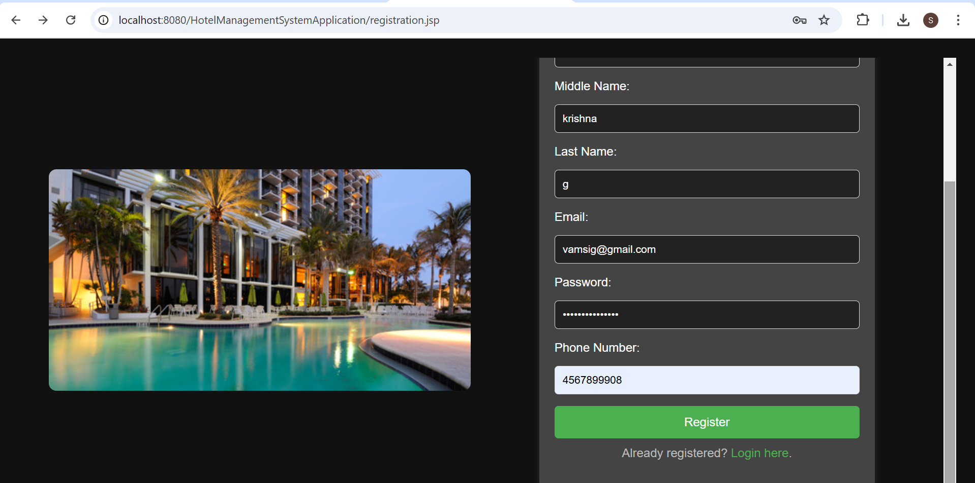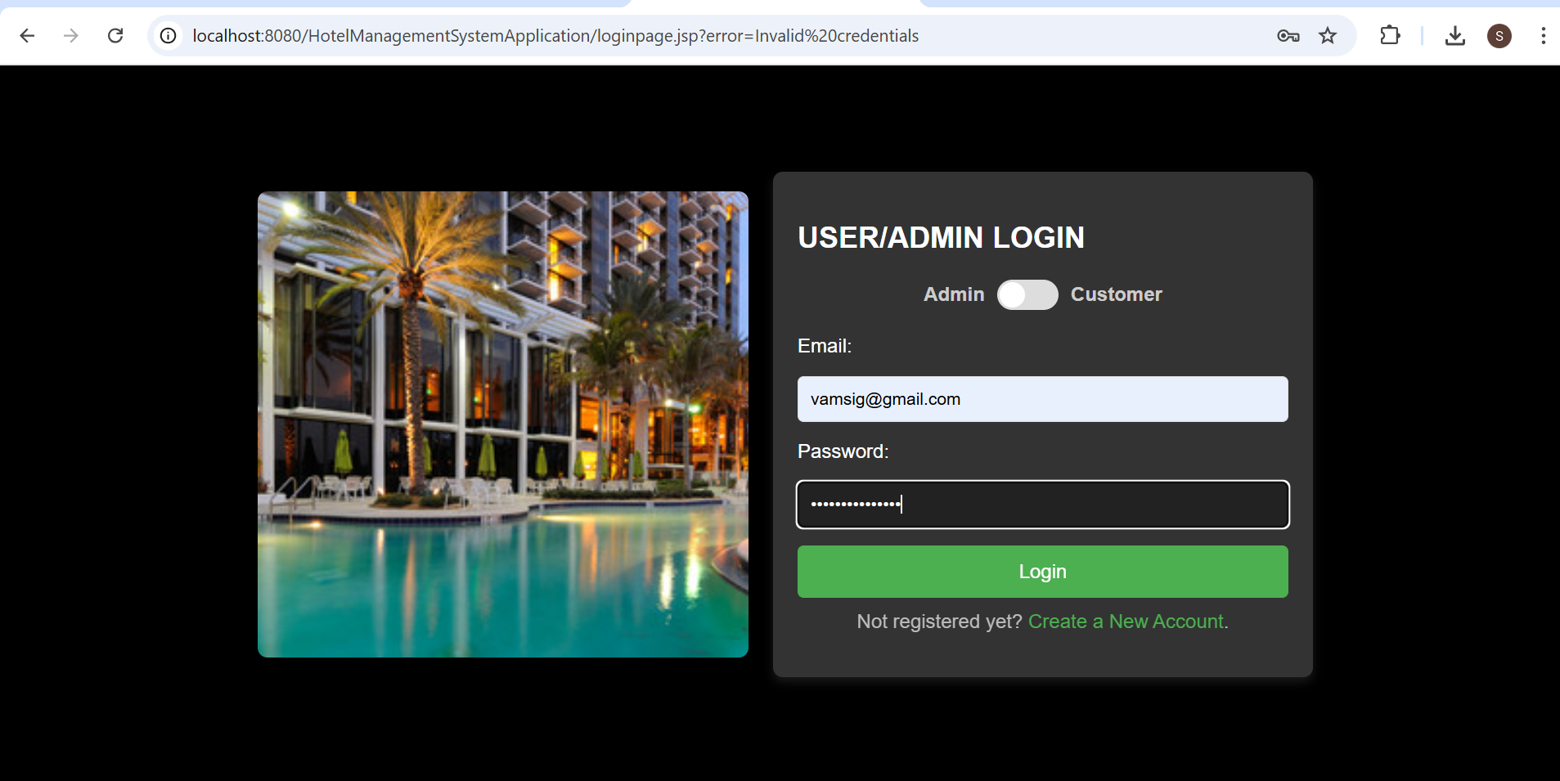

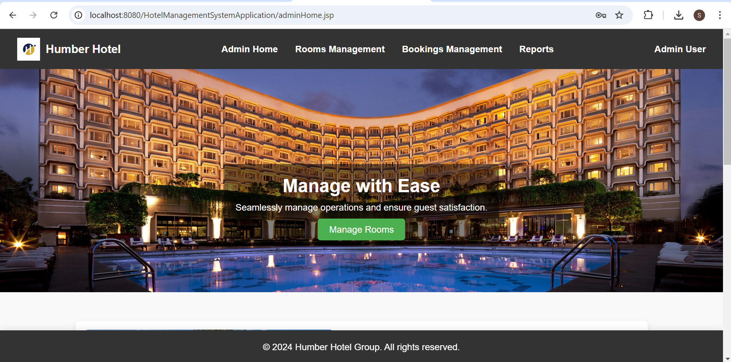

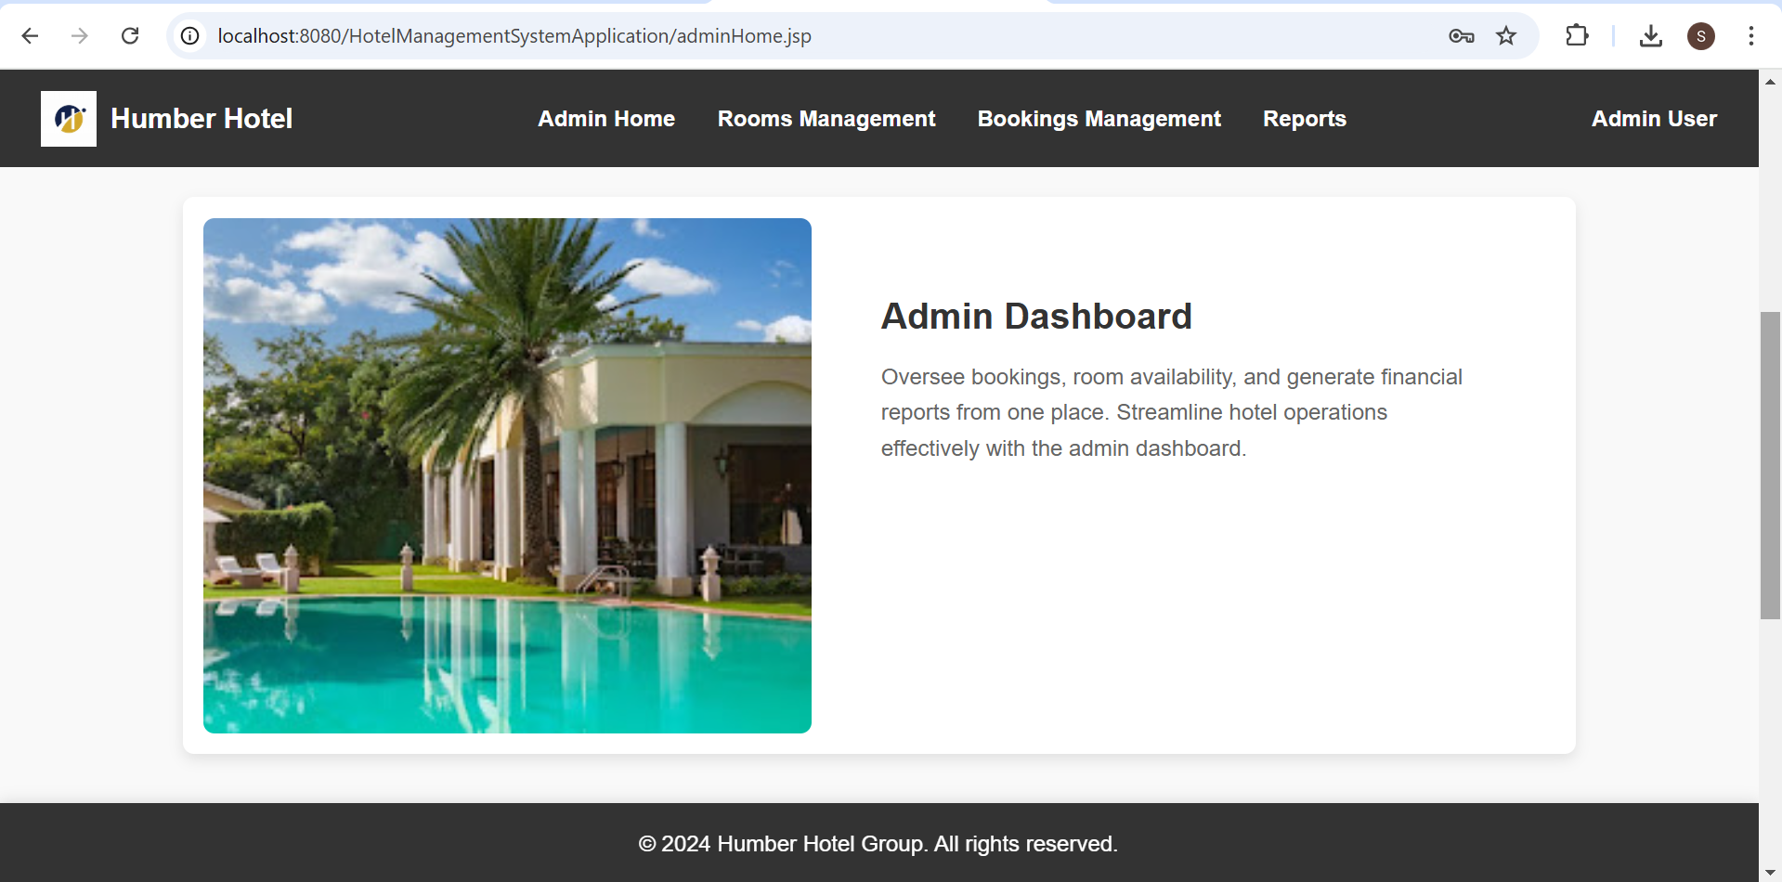

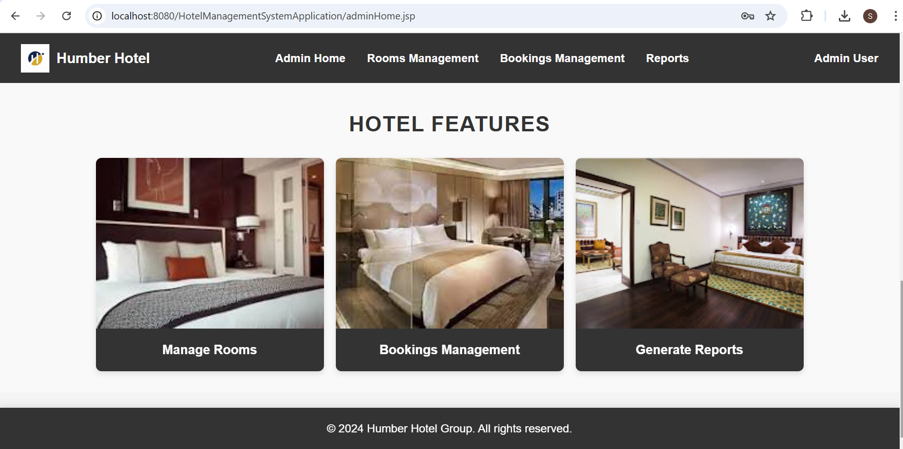

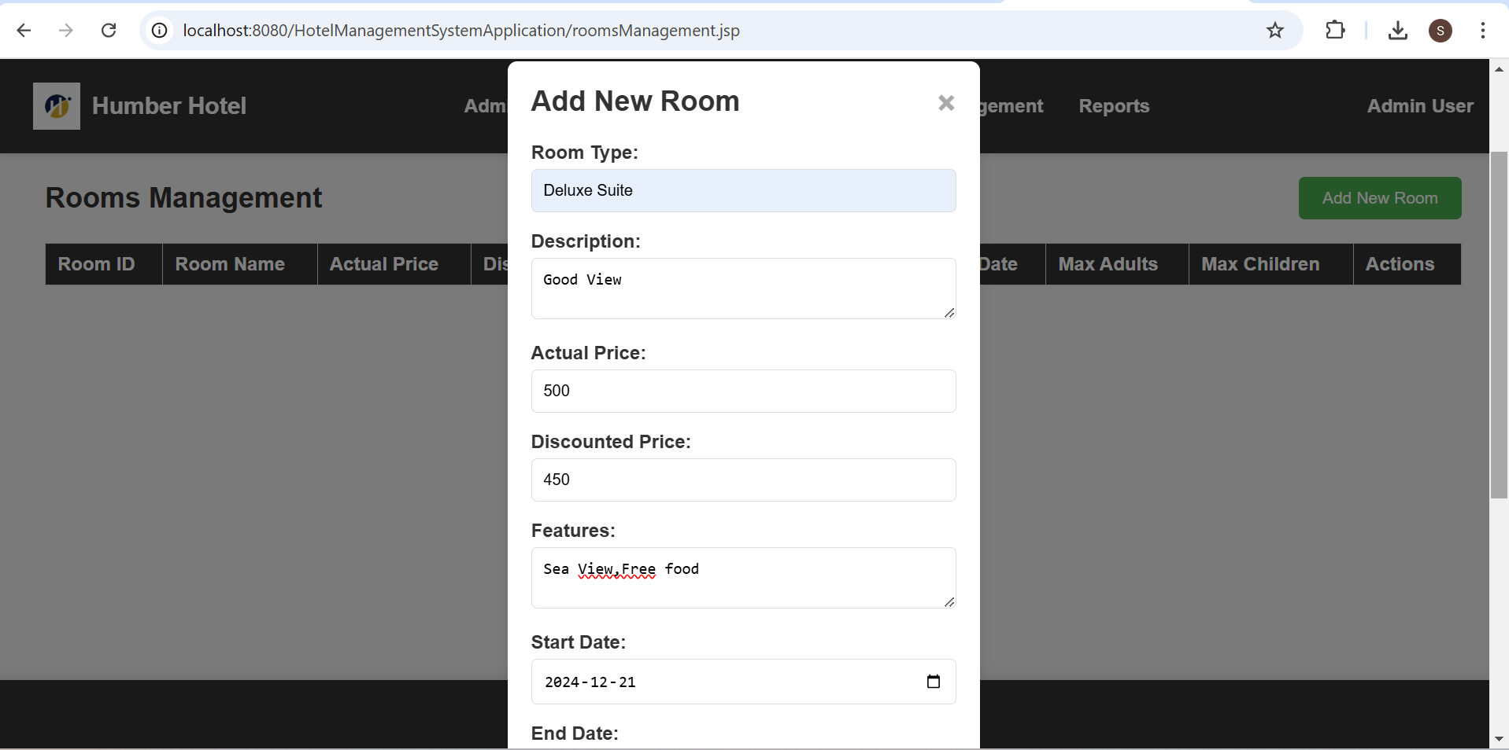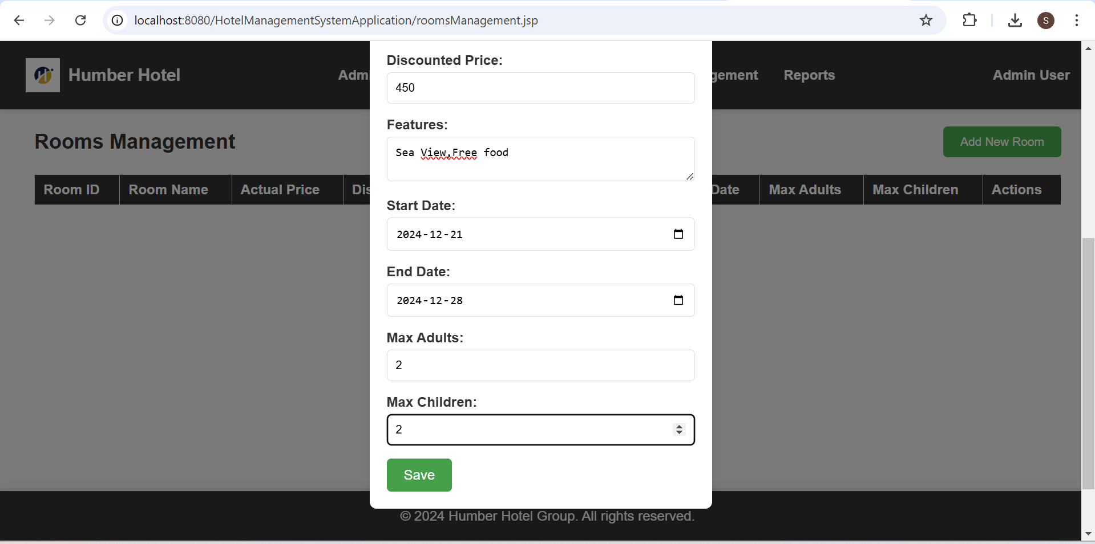

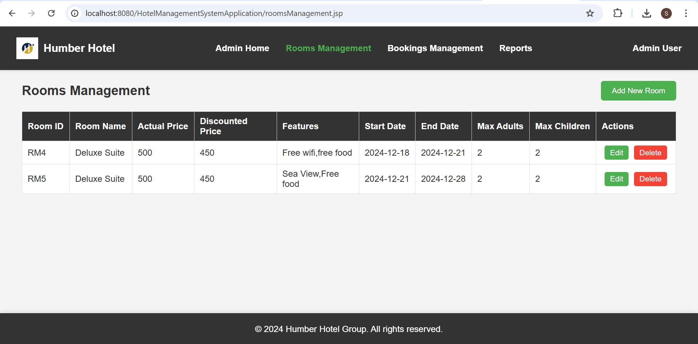

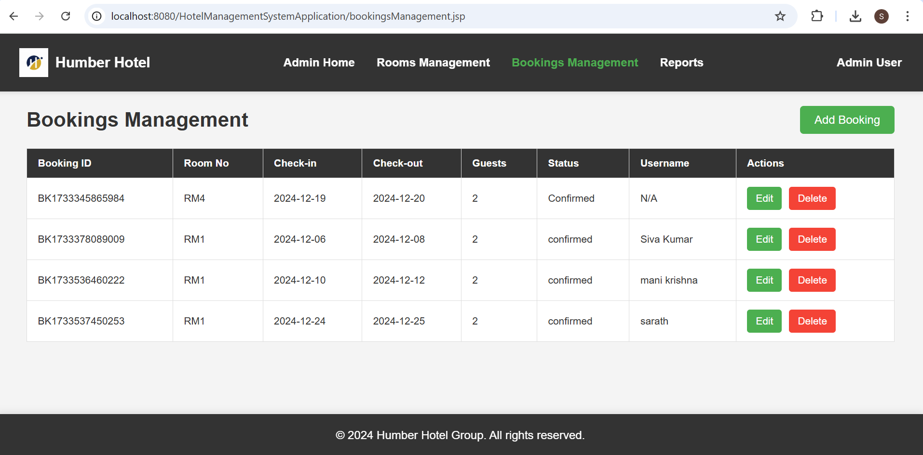

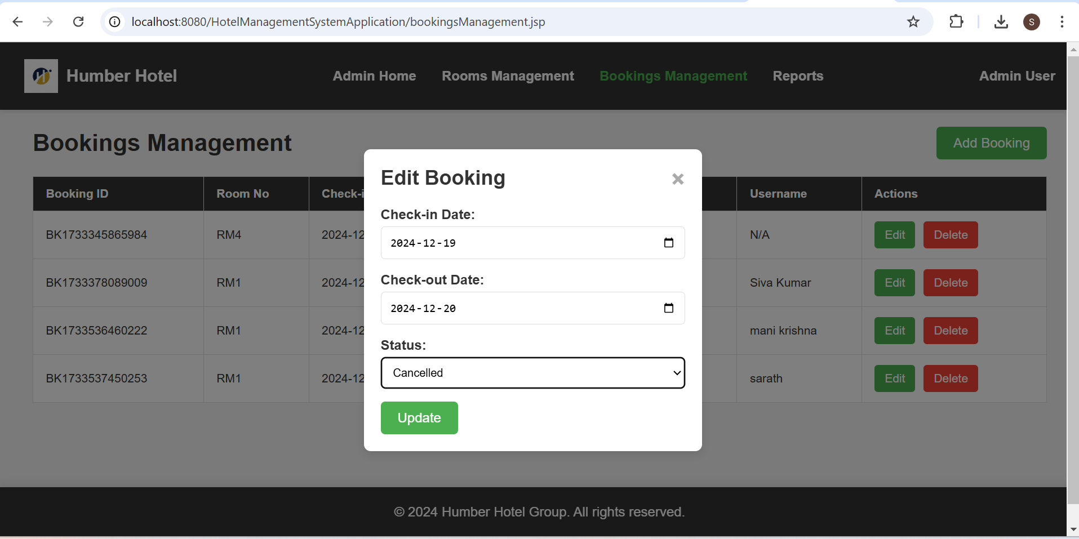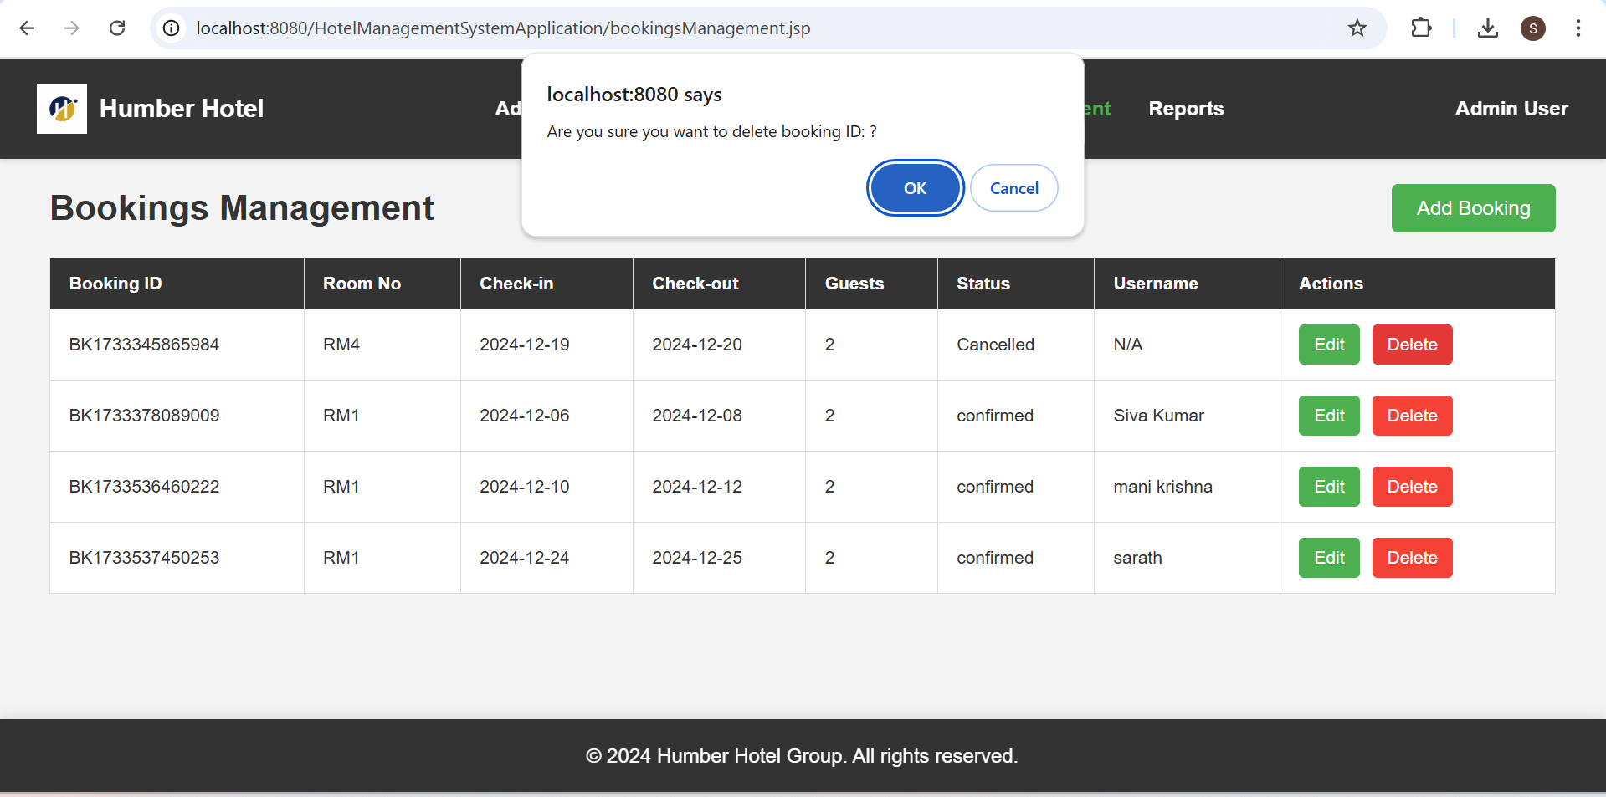

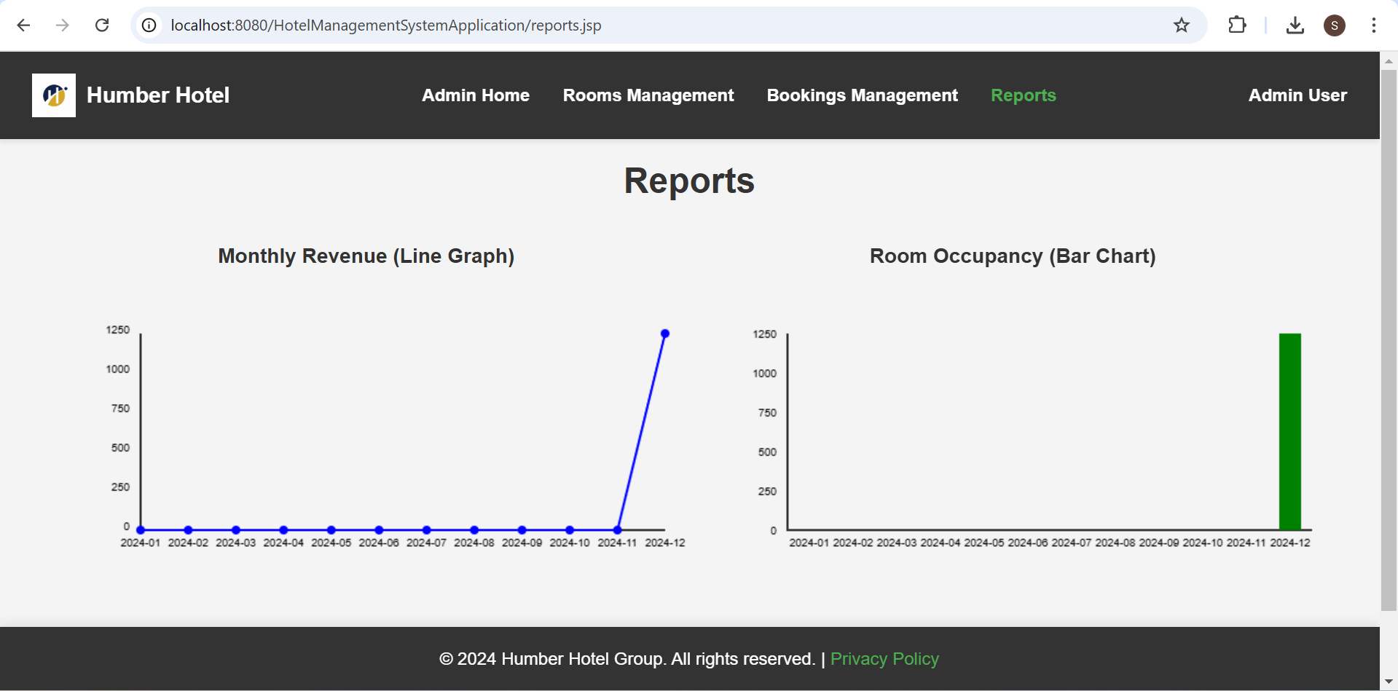

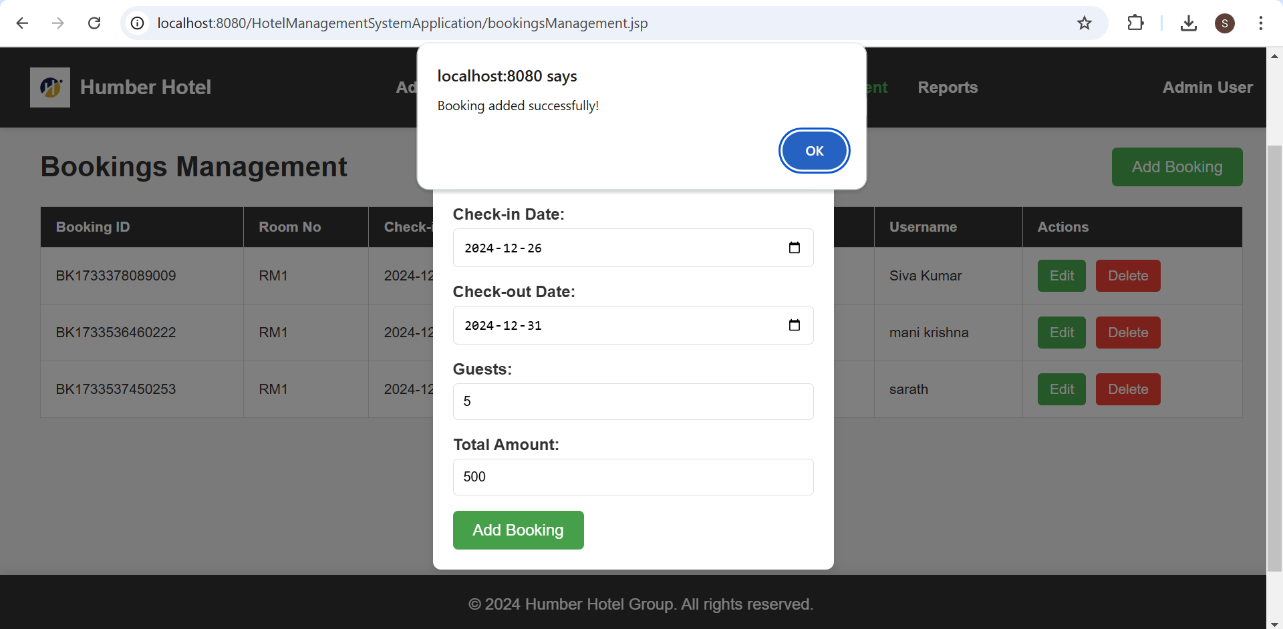

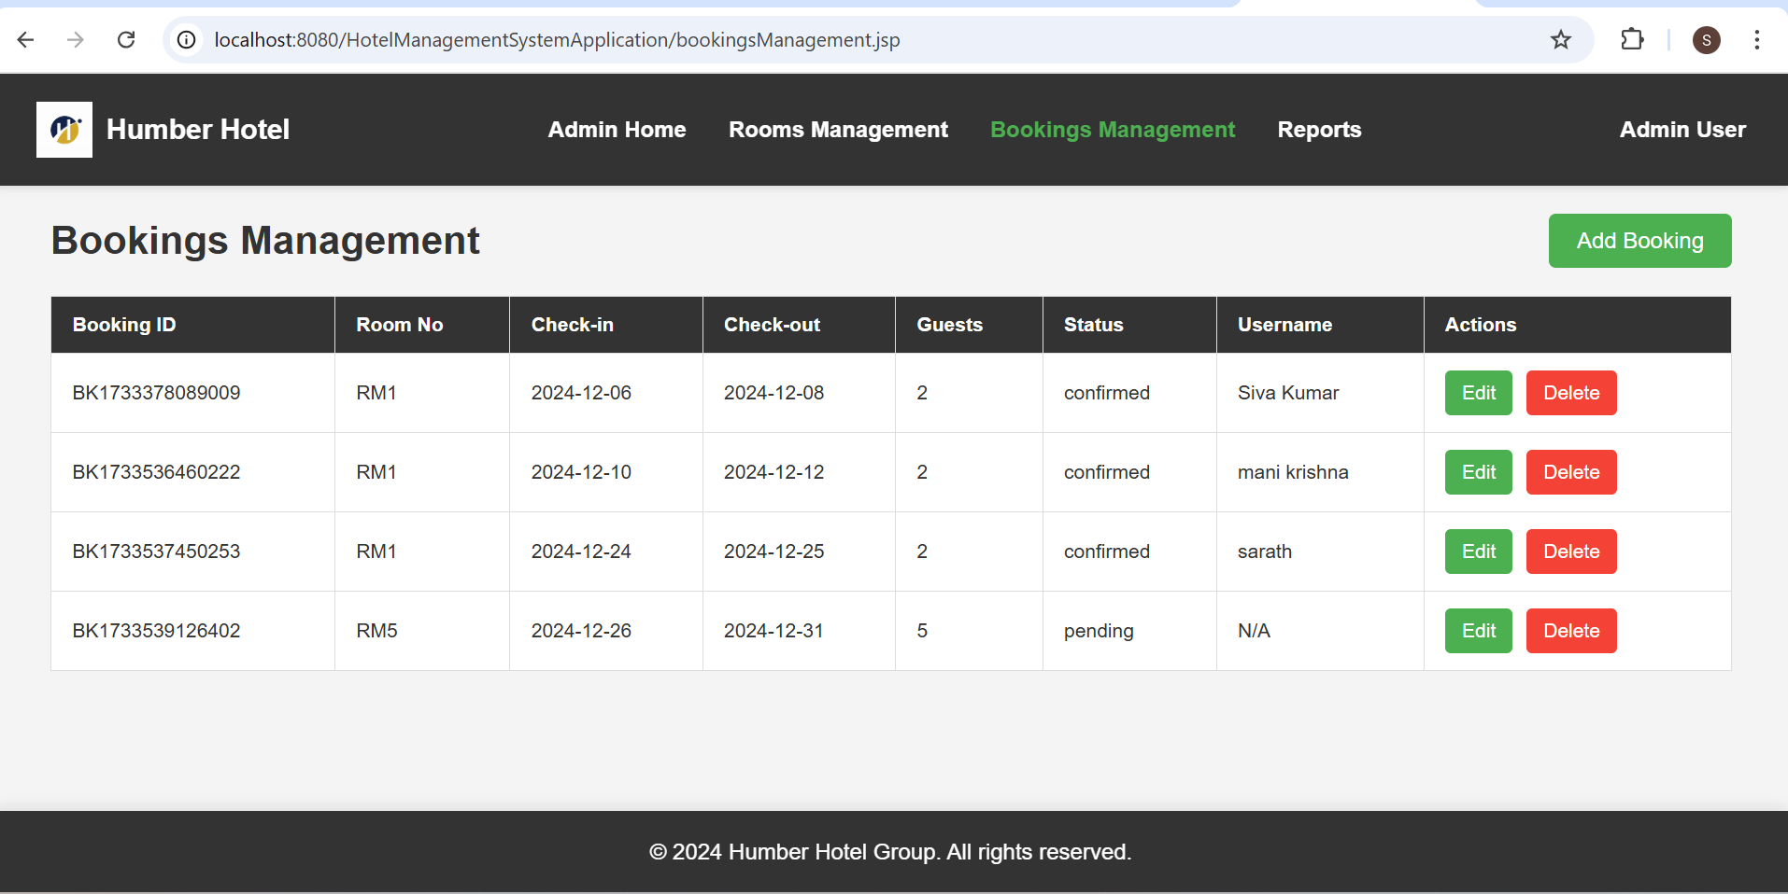

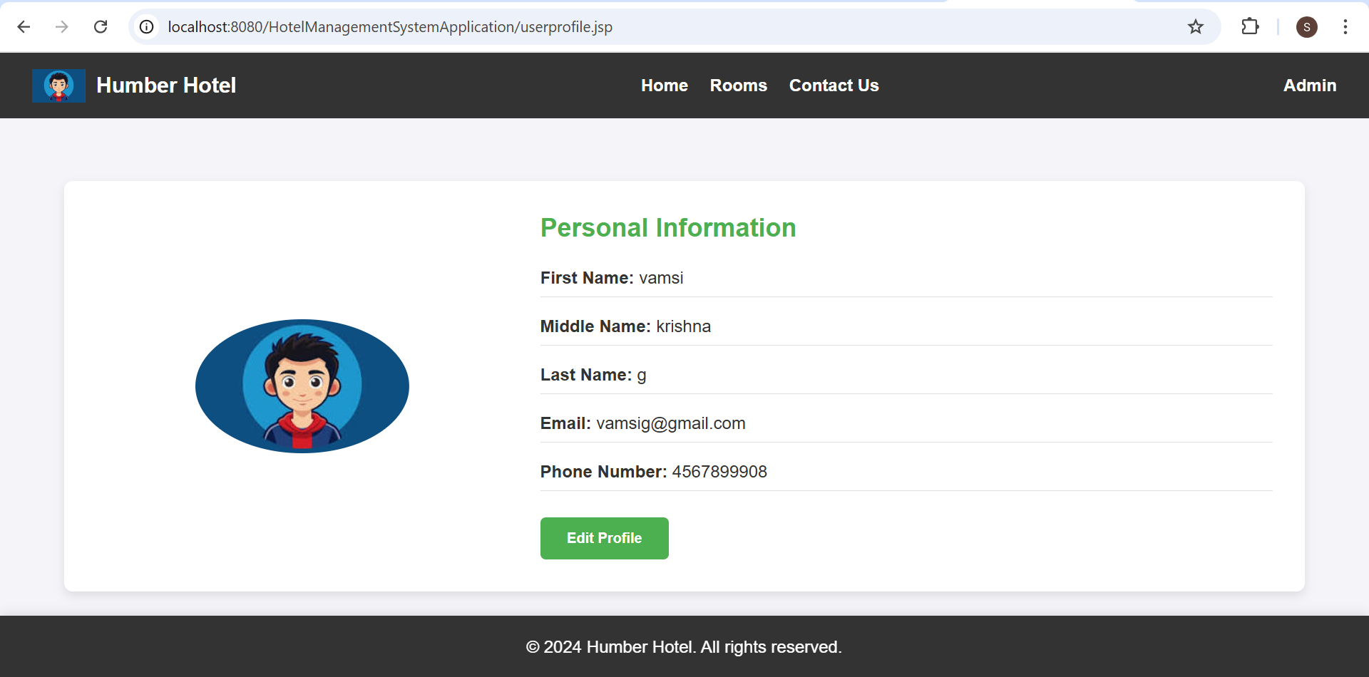

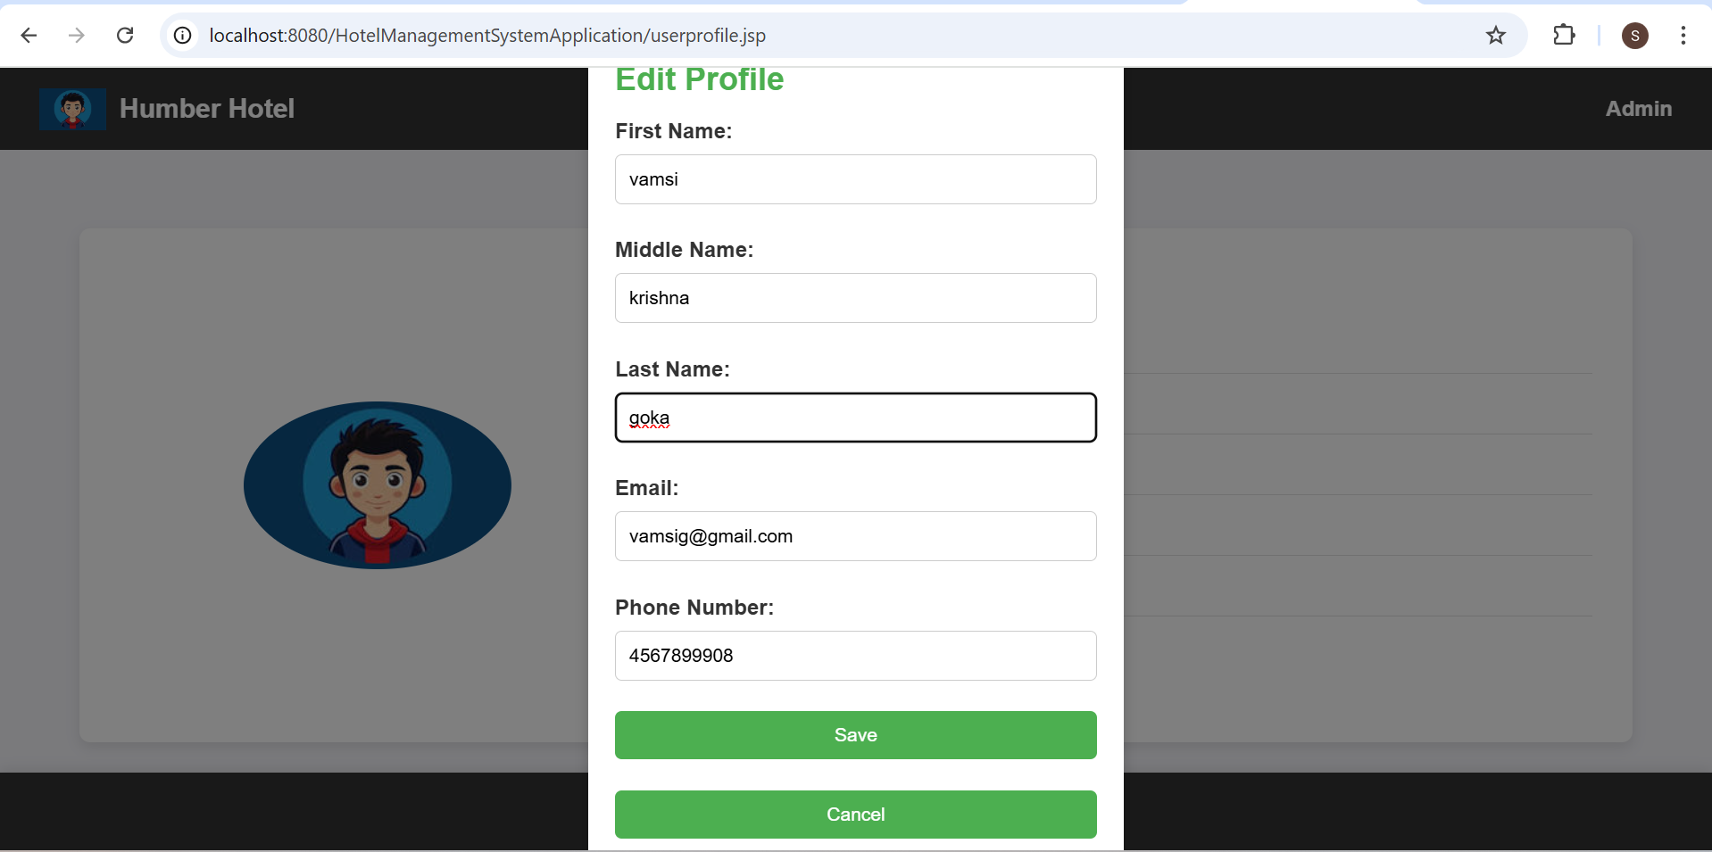

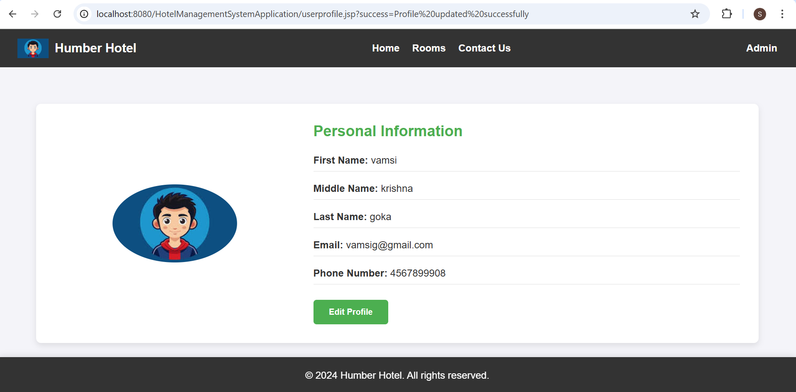

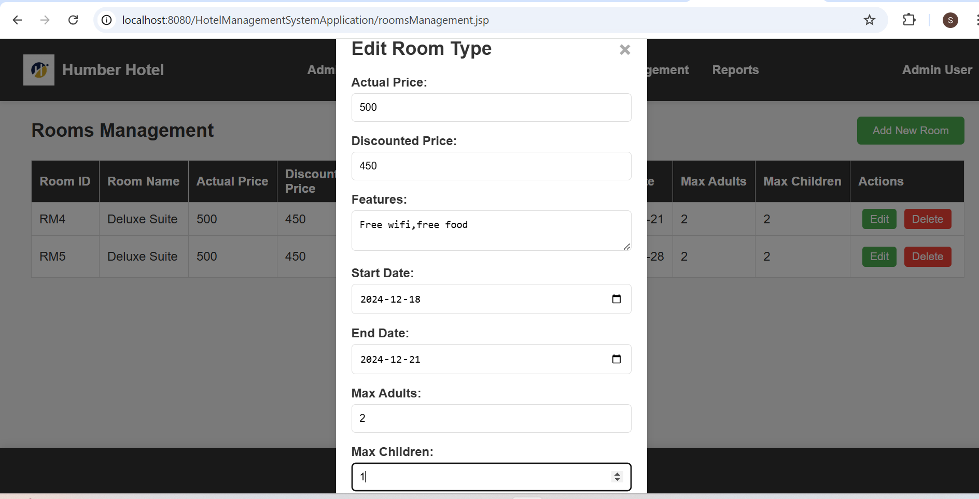

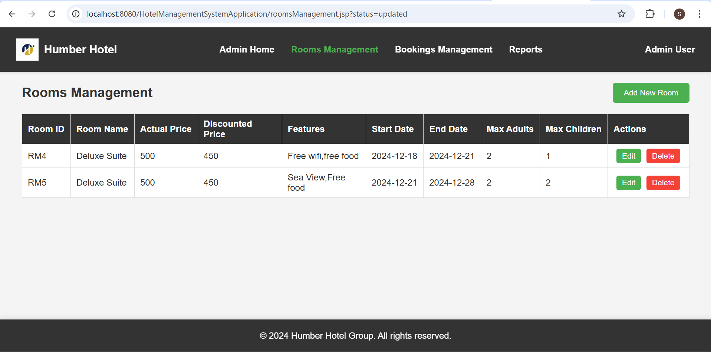

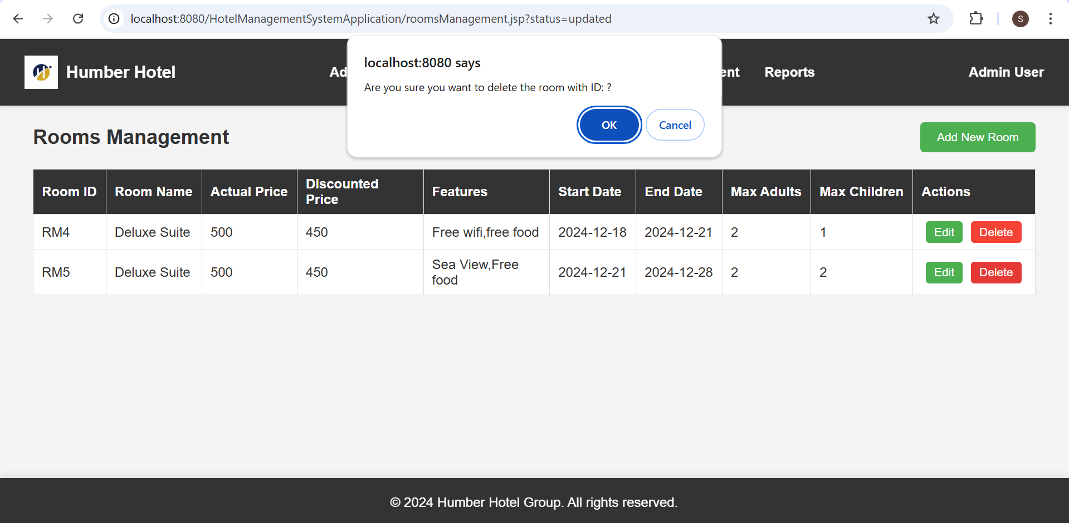

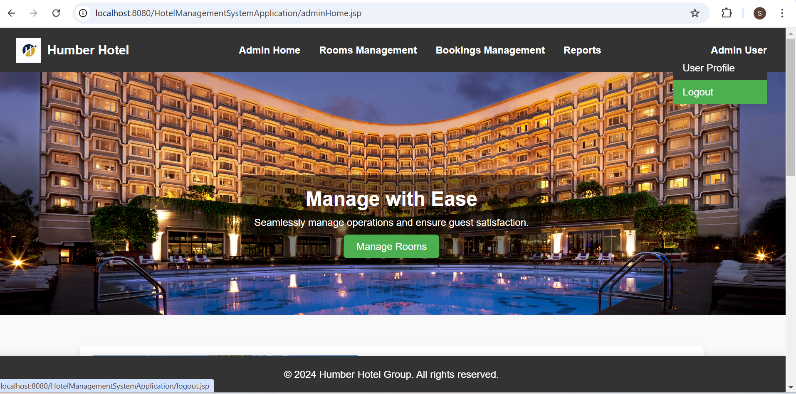

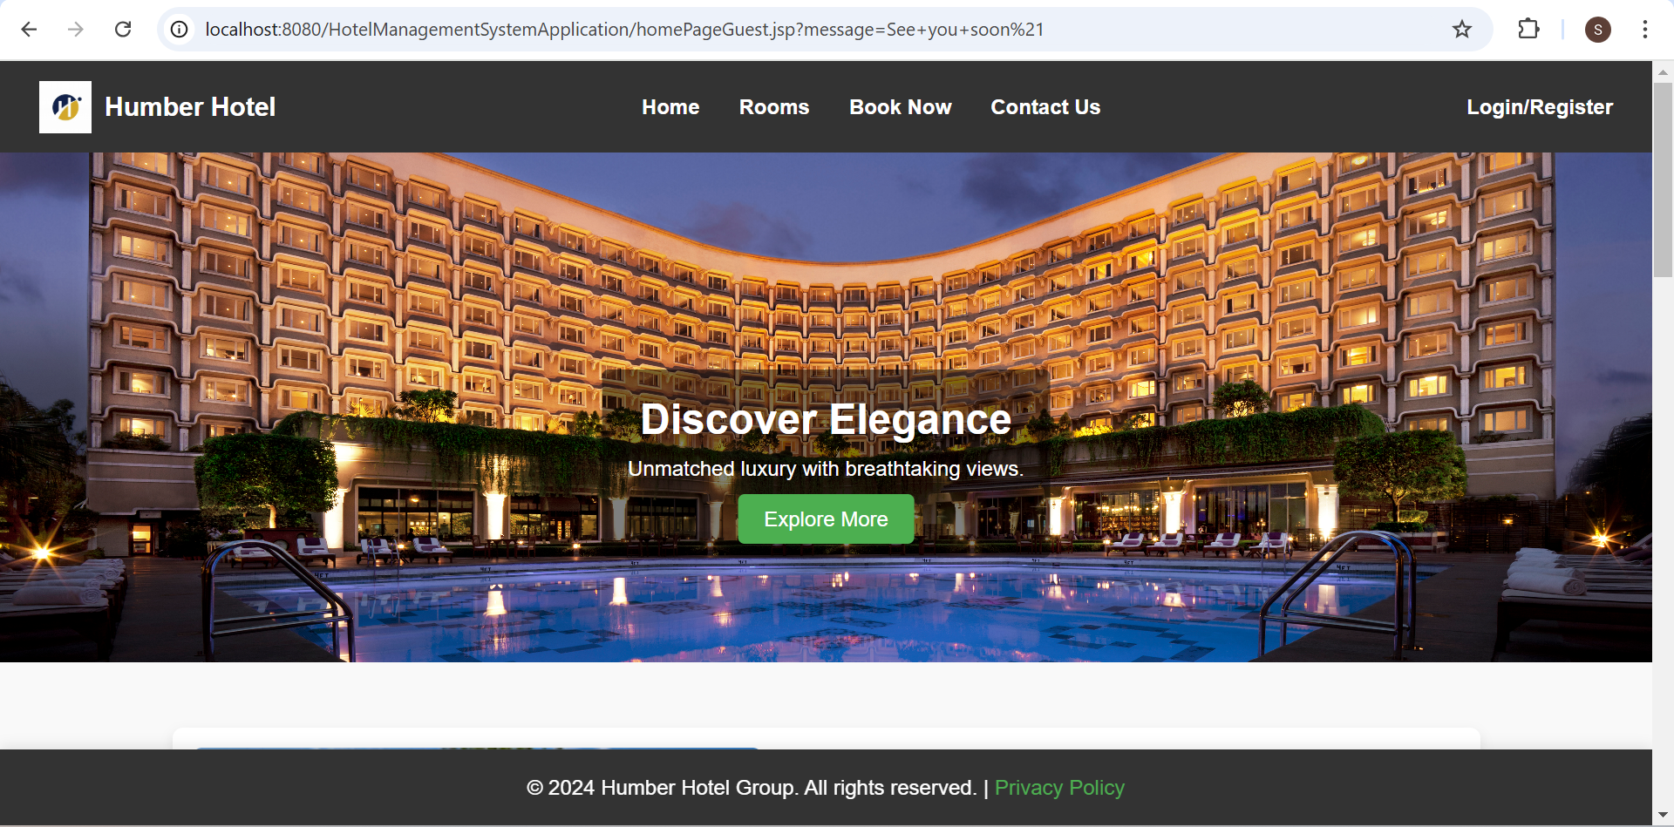

**THANK YOU SIR**